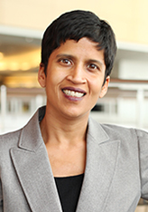
Professor Shoba Wadhia

Director of the Center for Immigrants' Rights

Samuel Weiss Faculty Scholar and Clinical
Professor of Law

Penn State Law, University Park, Pa.

Tuesday, November 10, 2015
12:15 - 1:30 pm
UC College of Law Room 114

Authentic Mexican Food will be provided!

In Texas v. United States, the United States maintains that the implementation of Deferred Action for Childhood Arrivals (DACA) and Deferred Action for Parents of Americans and Lawful Permanent Residents (DAPA) is a right of prosecutorial discretion since the U.S. has “neither the resources, the capability, nor the motivation to uproot and deport millions of unauthorized aliens,” while 26 states believe it is beyond the President’s executive power.

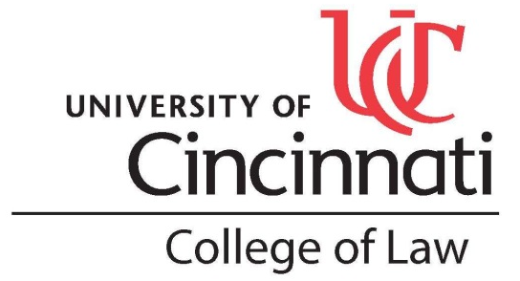
Professor Shoba Wadhia will be here to discuss this issue with her newly published book, Beyond Deportation which "is the first book to comprehensively describe the history, theory, and application of prosecutorial discretion in immigration law." Beyond Deportation has been described as, "[t]he definitive word on the all-important tool of prosecutorial discretion in immigration enforcement," and "timely and incredibly helpful for scholars, students, policymakers, and leaders."

More information on her book can be found at:
http://www.fromthesquare.org/?p=7655#.Vhf84flVikr and amazon.com
Beyond Deportation is available in the Marx Law Library
for anyone interested in reading her work.

